3D Graphics

📘 Definition
# Source: AI Source: Provided by: [Data Path: Persons Table -> ID Column: 1, Name_En Column: Motasem Essam] -> From: [ChatGPT] on [5/2/2026]
3D Graphics are visual images created using computers that have three dimensions: width, height, and depth. This extra dimension makes objects look more realistic, as if they exist in real space.

🎨 What do 3D graphics look like?
# Source: AI Source: Provided by: [Data Path: Persons Table -> ID Column: 1, Name_En Column: Motasem Essam] -> From: [ChatGPT] on [5/2/2026]
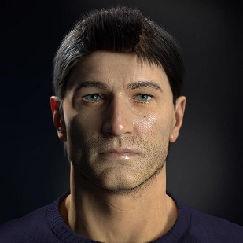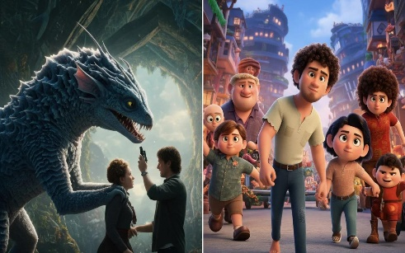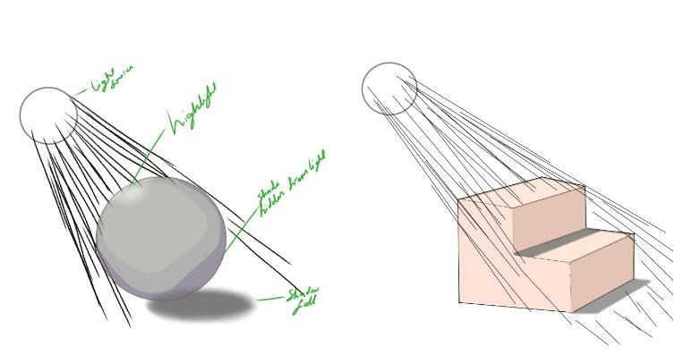
These visuals show:
- Realistic characters and objects
- Depth, shadows, and lighting
- Environments that feel “alive” and immersive

🧠 Simple Example
# Source: AI Source: Provided by: [Data Path: Persons Table -> ID Column: 1, Name_En Column: Motasem Essam] -> From: [ChatGPT] on [5/2/2026]
Movies like Avatar and games like Grand Theft Auto V use 3D graphics to create lifelike worlds where you can move in all directions.

⚙️ Key Features
# Source: AI Source: Provided by: [Data Path: Persons Table -> ID Column: 1, Name_En Column: Motasem Essam] -> From: [ChatGPT] on [5/2/2026]
- Has depth (looks realistic)
- Uses lighting, shading, and perspective
- Objects can be rotated and viewed from different angles
- Common in games, movies, simulations, and virtual reality

🚀 In short:
# Source: AI Source: Provided by: [Data Path: Persons Table -> ID Column: 1, Name_En Column: Motasem Essam] -> From: [ChatGPT] on [5/2/2026]
3D Graphics = realistic visuals with height, width, and depth.

